1. Mention current wind energy and wind turbine situation in California

2. Mathematically explain the model we are using. + The comparison that using box-cox is better.

The MS-AR models we use in this paper is detailed described in the paper ‘Markov-switching autoregressive models for wind time series’(2012) by Pierre Ailliot , Valérie Monbet.

Below, we briefly explain the difference between Markov chain, hidden Markov model, auto-regressive model and MS-AR model. (All the Markov chain here is first-order Markov, and Auto-regressive is of second order)

(St∈{1,...,S}. represents the state at time t. yt denotes the wind speed at time t. The dark one means the value we can observe; white circle means the value is latent)

(1) Markov chain

Let St∈{1,...,S}. A sequence(s1,...,st) is a Markov chain with following Consumption.

p(s1,...,st)=p(s1) $\prod_{u=2}^{t}{p(su|su-1)}$

Meaning that the conditional distribution of St only depends on the value of St-1. And is independent of other past conditions.

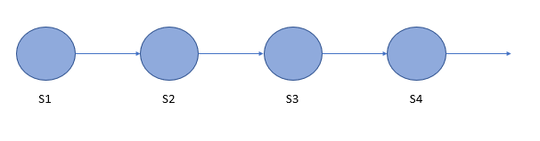

(2) Hidden Markov model

Hidden Markov model assume a hidden (i.e., unobserved,) sequence of states St, and observation yt is drawn from the distribution associated with its state

The conditional distribution of St only depends on the value of St-1.

And the conditional distribution of the observation yt only depends on the state St.

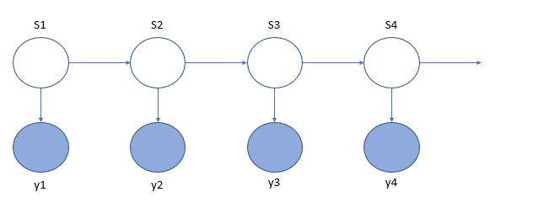

(3) Auto-regressive model

An autoregressive process of order p or AR(p) satisﬁes

Yt −µ = $\sum_{j=1}^{p}{αj\left(Yt-k -µ\right)+εt}$.

The conditional distribution of yt depends on the previous yt, and coefficients evolve in time. State St is not relevant to the distribution in this case. With AR(2) as in the graph, meaning that yt depends on yt-1 and yt-2.

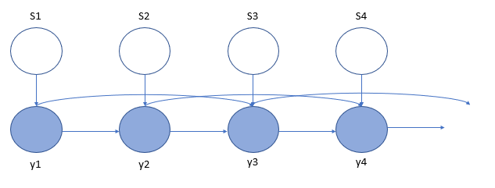

(4) MS-AR model

MS-AR model is a combination of Hidden Markov model and auto-regressive model.

The conditional distribution of St only depends on the value of St-1.

And the conditional distribution of the observation yt depends on the value of St, and depends on yt-1 and yt-2 as we are using a AR(2).

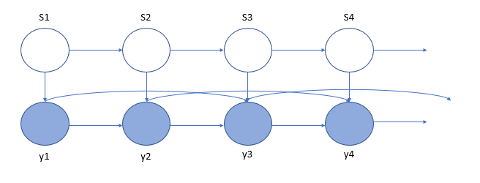

In our application of the MS-AR model, we assume it to be homogenous. Meaning that the transition probabilities P(St=s’|St-1=s) are constant in time.

3. our finding

3.0 the data

QQ-plot of the marginal distribution for the fitted model (y-axis) against the sample distribution (x-axis).

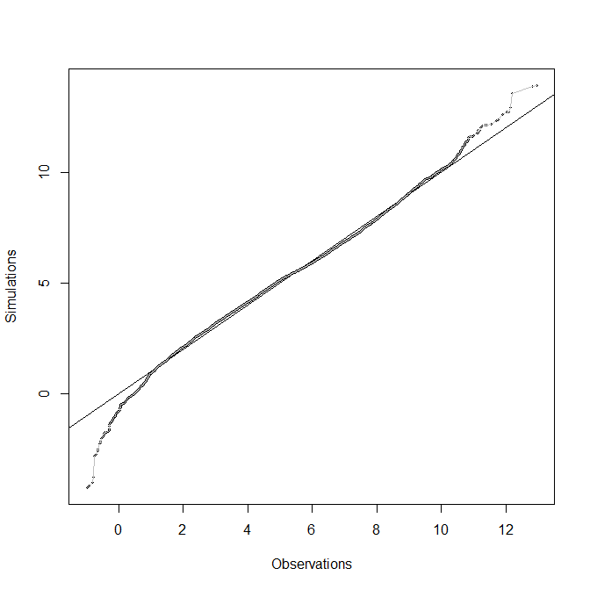

autocorrelation functions

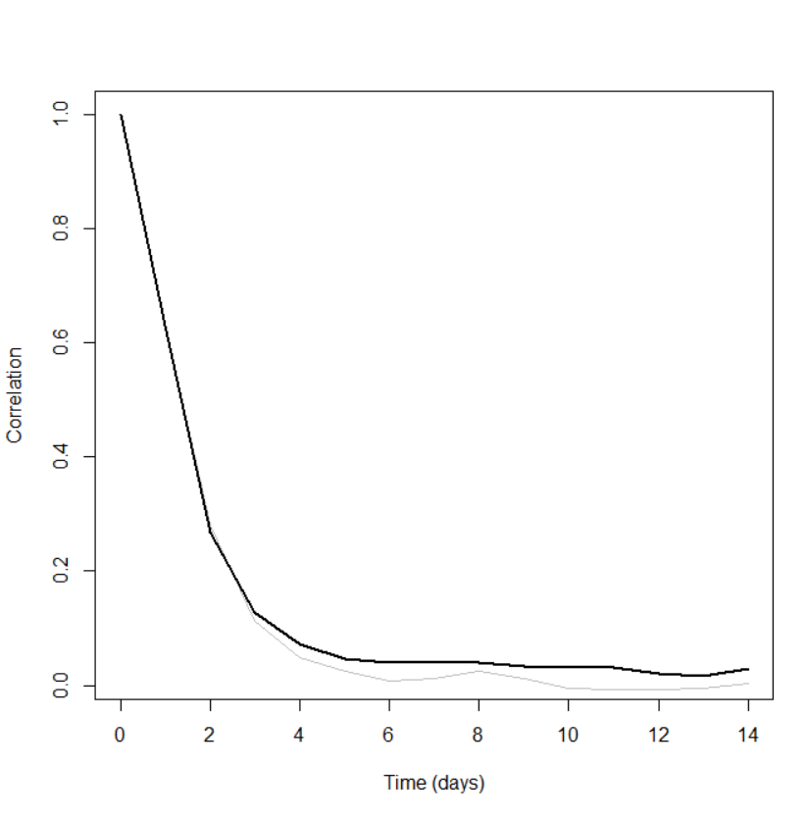

statistics of mean duration over a level

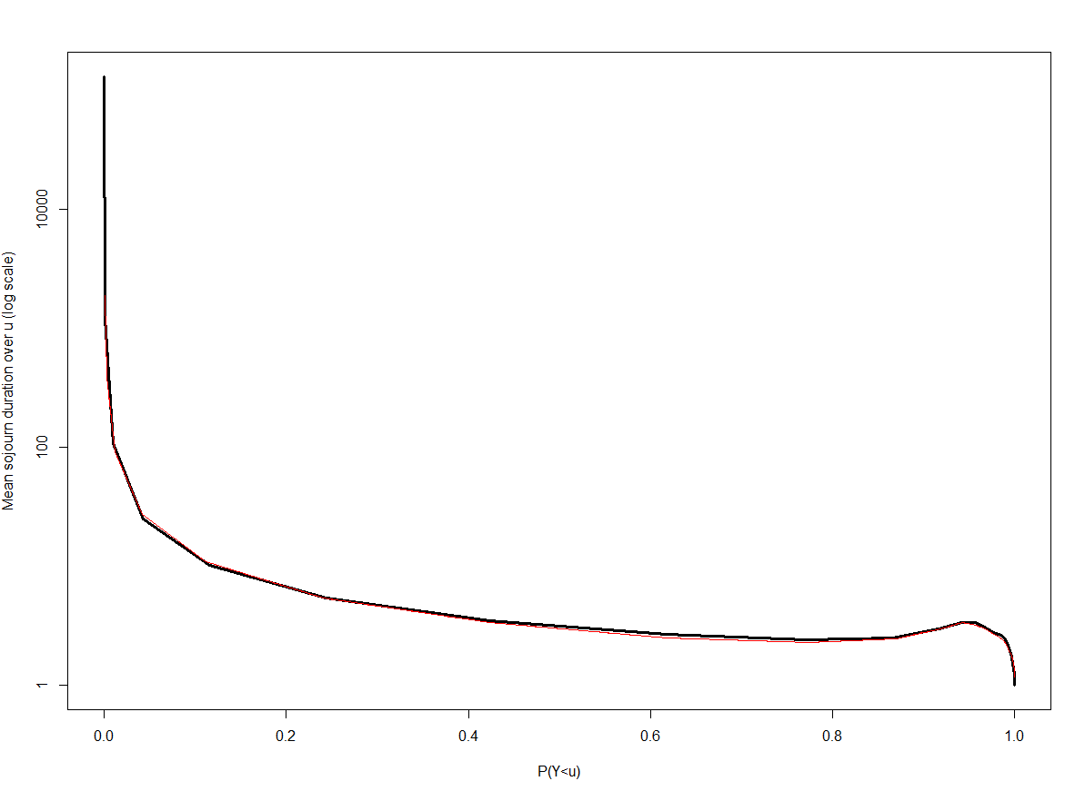

statistics of mean duration under a level

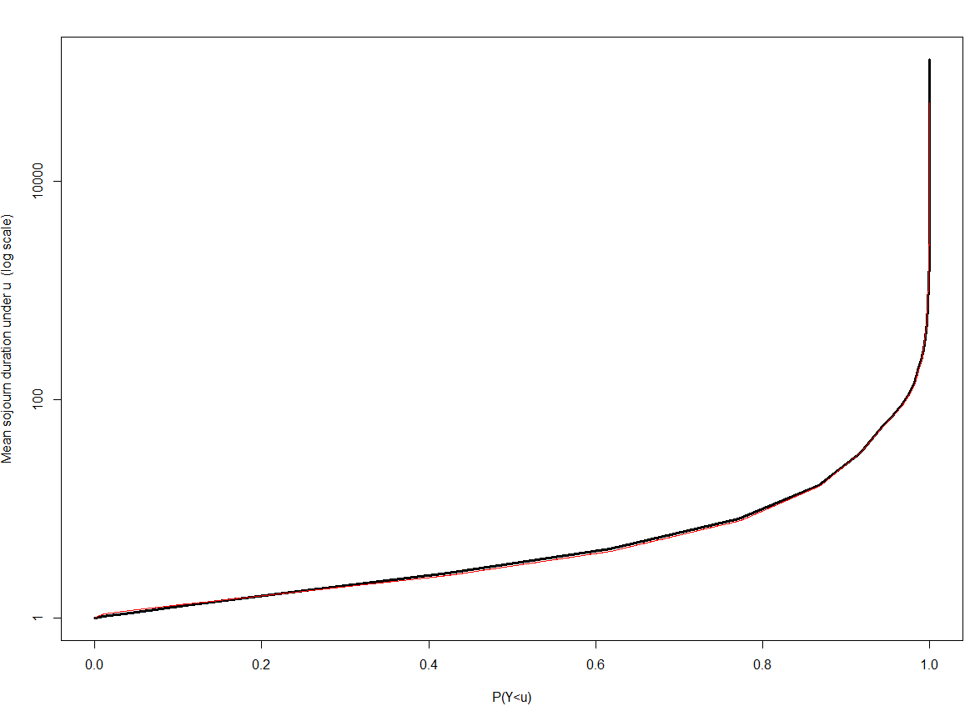

Regime plot, regime materialized by grey boxes

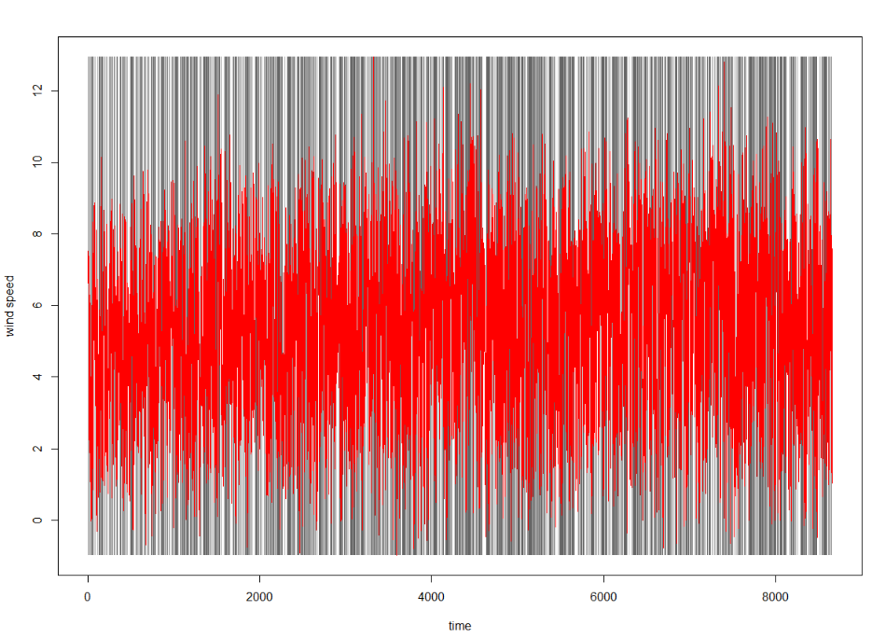

3.1 the optimum number of regime and degree of AR

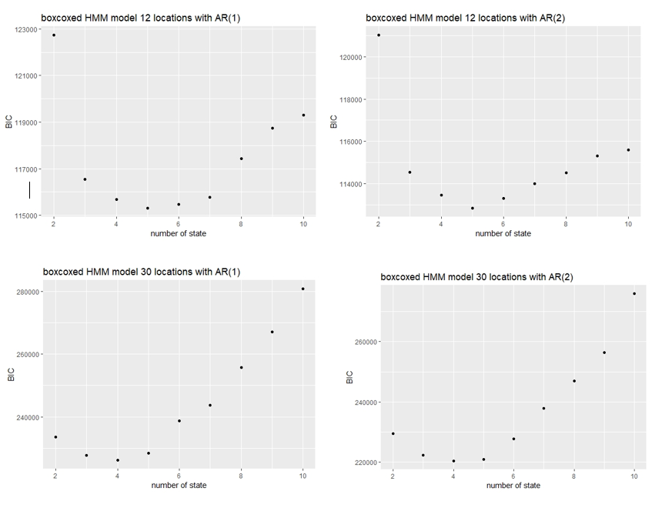

3.2 the transition matrix and wind-speed

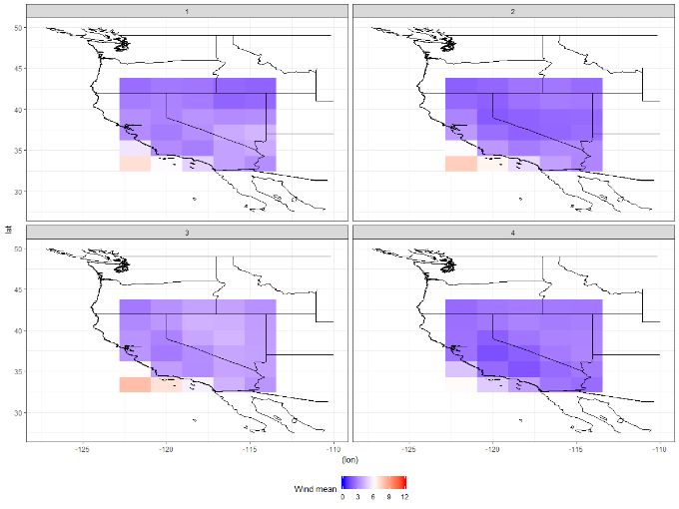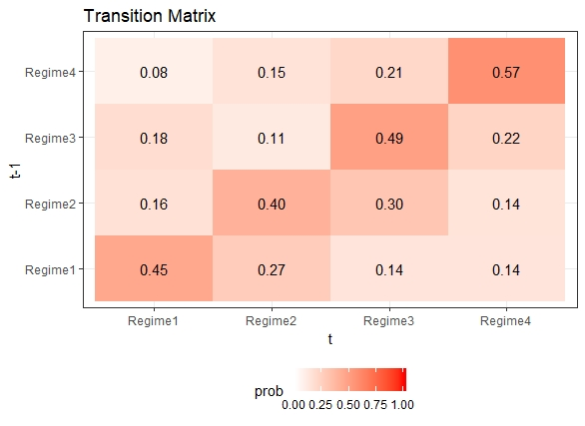

3.3 prediction comparison (iterated vs Viterbi vs dummy)

Iterated has the lowest RMSE, meaning the best one.

4. Conclusion and solution for the wind turbine.